STEPS FOR MyChart ACTIVATION
1) Download the MyChart app on your smartphone device through the App Store (Apple Phones) or the Google Play store (Android phones).

**Key Step**Once inside the MyChart app, you will want to select our organization (PPOC in yellow letters)

2) Access your email and locate the email sent by:
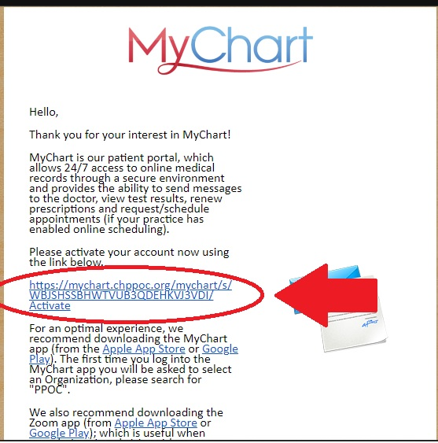
Bridgewater Pediatrics
<donotreply@chppoc.org>

3) Sign up using the hyperlink that is included in the email (the hyperlink contains your unique Activation Code which is automatically plugged in when you access the sign up process via hyperlink). Keep in mind when it asks for Date of Birth, it will be your PERSONAL date of birth, and not your child’s.

Your username is defaulted to your first and last name in one word (E.g John Smith = Johnsmith)

4) Access MyChart via the mobile app, or at: https://mychart.chppoc.org/MyChart/Authentication/Login?

